Toronto rental affordability
  - Figure explanations
The map shows where renters face more housing pressure. The dot chart adds income and rental costs, and the Regent Park and South Parkdale comparison shows how housing support may help explain the differences.

1. Where renting puts more pressure on income
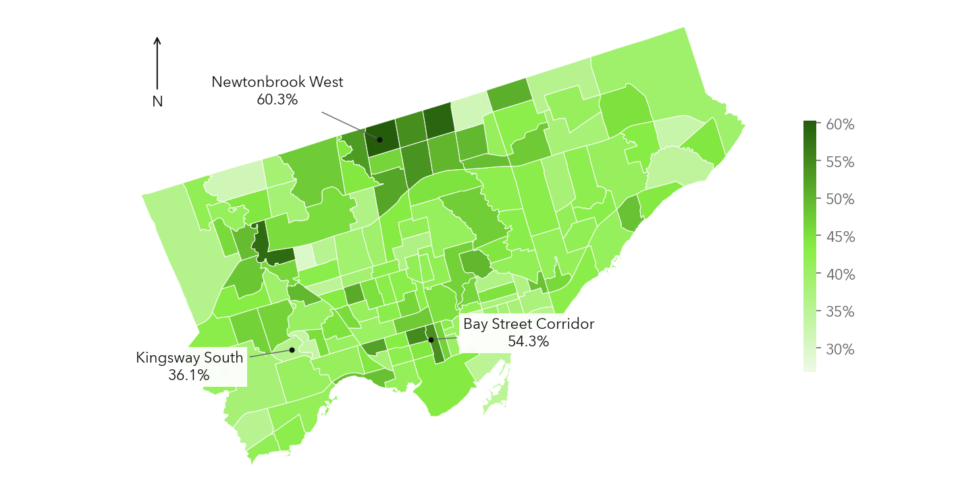
Figure 1. Toronto neighbourhood profiles, 2011. Darker green means more renters spend at least 30% of income on housing.
This map shows where renters in Toronto spend a large share of their income on housing. Each area is a neighbourhood. The darker the green, the more renter households spend at least 30% of their income on housing. That means housing takes at least $30 out of every $100 they earn. Newtonbrook West stands out at 60.3%, compared with 36.1% in Kingsway South. Put simply, about 60 out of 100 renter households in Newtonbrook West crossed that mark, compared with about 36 in Kingsway South. Bay Street Corridor is also high at 54.3%. The difference matters because the most expensive place to rent is not always the place where renters face the most pressure. What people earn and what help they receive also shape what they can afford. The map gives us the starting point, it shows where the pressure is higher. It does not tell us why every household is struggling or why people chose to live there. The dot chart on the next page adds income to the picture. The final comparison then brings rental costs and housing support together. These figures describe conditions in 2011, rather than rental prices today.

2. How income and rental costs fit together
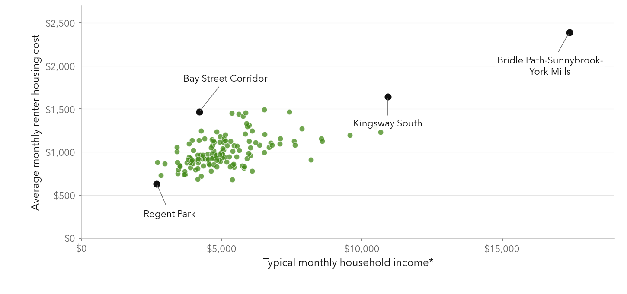
Figure 2. Toronto neighbourhood profiles, 2011. Typical monthly income is annual median household income divided by 12, before tax, using 2010 income.
Each dot in this chart is a Toronto neighbourhood. Moving to the right means a higher typical monthly household income. Moving up means a higher average monthly rental housing cost. Most dots rise as they move right, so neighbourhoods with higher incomes tend to have higher rental costs. But the named examples show why the relationship needs a closer look. Kingsway South has a typical monthly household income of about $10,921 and an average rental housing cost of $1,640. Bay Street Corridor has a much lower typical income of about $4,197, while its rental housing cost is still $1,467. The rental costs are fairly close, but the income figures are far apart. This gives the map more context: a price that looks similar on paper can sit within very different income conditions. There is one limit to keep in mind. The income figures include owners and renters, while the housing costs cover renters. We cannot divide these numbers to work out what an actual renter spends from their income. The chart shows a neighbourhood pattern, not individual budgets. It also leaves another question open: what helps explain lower rental costs in some lower-income areas? The Regent Park and South Parkdale comparison adds housing support to that picture.

3 Why Regent Park and South Parkdale look different
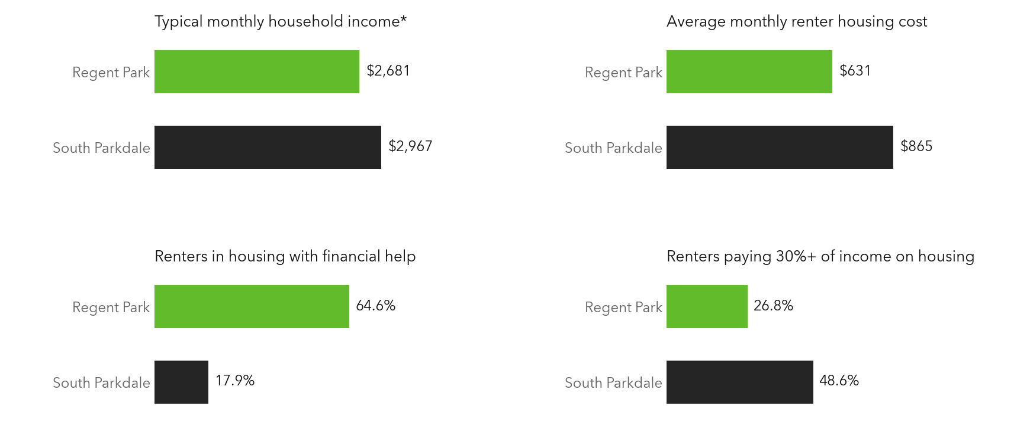
Figure 3. Toronto neighbourhood profiles, 2011. Income includes owners and renters. The other measures describe renter households.
This comparison helps explain why rental prices alone do not tell the whole story. Regent Park has a slightly lower typical monthly household income than South Parkdale: about $2,681 compared with $2,967. But its average monthly rental housing cost is also lower, at $631 rather than $865. That is $234 less each month. There is another clear difference. In Regent Park, 64.6% of renter households live in housing with financial help, compared with 17.9% in South Parkdale. Regent Park also has a smaller share of renters spending at least 30% of income on housing: 26.8%, compared with 48.6%. So even though its typical household income is lower, fewer renters cross that housing-cost mark. Lower housing costs and more support may help explain the difference. The comparison does not prove that support alone caused it, because the homes and households in each area also differ. And the income figures include owners and renters, so they cannot be used to calculate an actual renter budget. Together with the map, these bars make the main point clear: to understand where renting is harder to afford, we need to look at what people pay, their income and the help available to them.

